Israeli-Palestinian Ramadan interfaith encounters

"Forgiveness" – October 5th 2006

On Thursday, October 5th, the first of two Ramadan interfaith encounters, jointly organized by the Interfaith Encounter Association and the Hope Flowers School, took place at the Hope Flowers School's campus in El-Khader.

We started a bit more than an hour before sunset with brief introduction that included an opening by Mr. Ibrahim Issa, Director of the Hope Flowers School, who welcomed participants to the school and gave a summary of the school's activities. Then Dr. Yehuda Stolov, Executive Director of the Interfaith Encounter Association, presented the activities its activities and thanked the school for hosting this study day and for the long and fruitful cooperation.
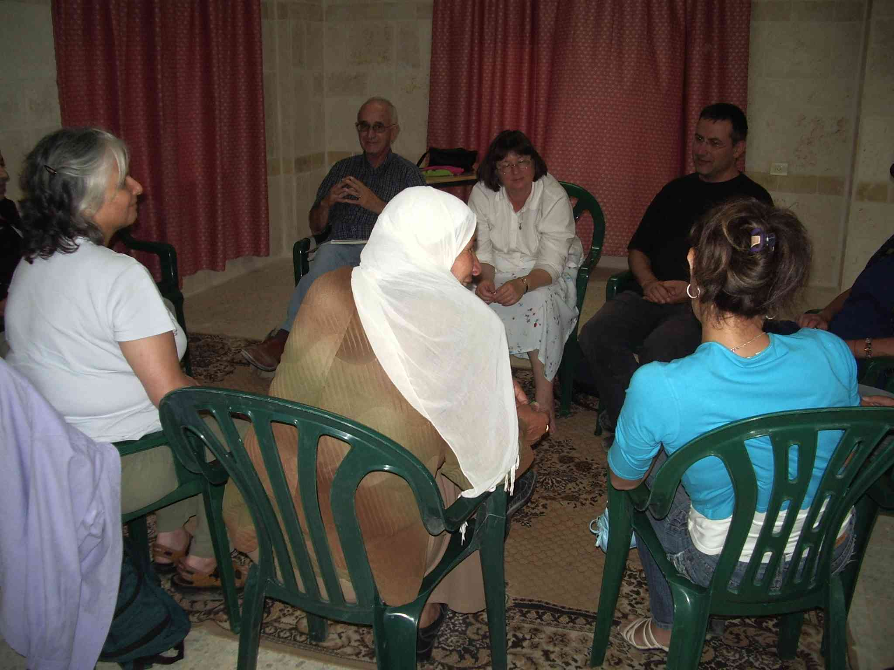

Moving to the program itself, Ibrahim explained the division of the 30 days of the month of Ramdan into three 10-day parts – the first focused on mercy, the second on forgiveness and the third on reward. This was the inspiration for this program of two study days (the second one will take place on Wednesday October 18th – see invitation below), each studying the theme of its days from the different religious perspectives. Then Yehuda asked participants to go to their small groups, introduce themselves and share stories of forgiveness – both when they forgave others and when they were forgiven by others.

Just before sunset we shifted to the dining room where we had a joint lovely and relaxed Iftar-dinner for the breaking of the fast, sitting together and informally chatting with each other. We were lucky to have a cook that not only prepared delicious food but was also well trained in the requirements for Kosher food so the vegetarian dishes were actually Kosher (and, of course, we also provided sealed supervised meals for the more strict).
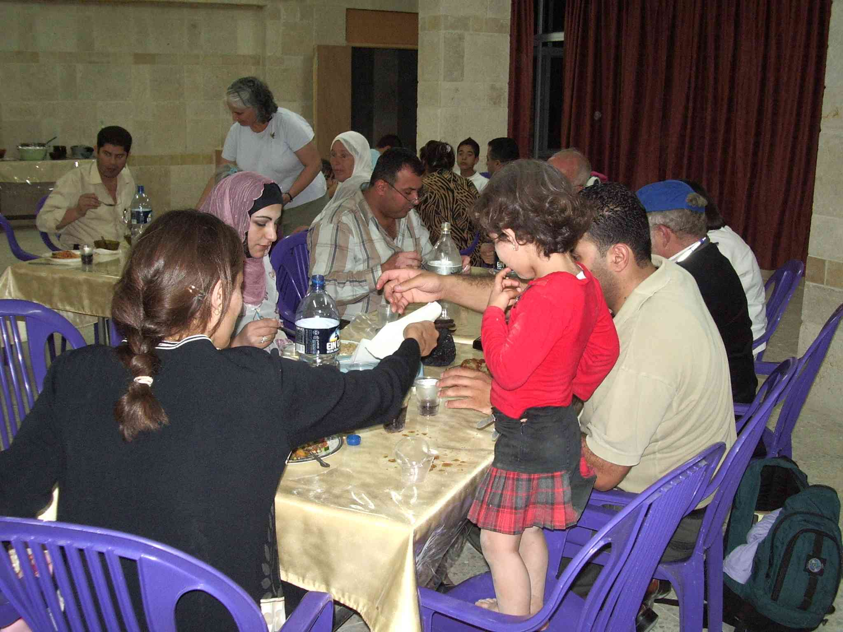

Following dinner we went back to the small groups to continue our conversations until the end of the evening.
Some of the issues that came up in the conversations were:
- "It is impossible to forgive another if I do not forgive myself. It is especially difficult to forgive lack of action"
- "It is difficult for me to forgive my mother, and to forgive myself for not working through the issues with her before her death"
- "Communication is most essential in asking and granting forgiveness"
- "Sometimes, even if it is impossible to talk, we can communicate in other forms, such as music, poetry etc."
- "An advice: when there is an unfinished business with someone we can write a letter to that someone, even if s/he will never read it (due to death or other reasons)"
- "Forgiveness comes from inner peace, resulting from knowledge and acknowledgement of the inner self, including peace with the dark side of myself"
- "Sometimes it is the other way around: that it is easier to acknowledge and forgive the other and then I can do the same for myself"
- "Koran calls upon people to know themselves and transform themselves before doing so with others"
- "The way is through listening and openness – the qualities of forgiveness"
- "In Islam these ten days are dedicated to asking forgiveness from God and fellow humans"
- "This is parallel to the Ten Days of Repentance in Judaism. In Judaism they are the first ten days of the month of Tishrey that is now, for a few years, parallel to Ramadan"
- "Sometimes it is difficult to forgive – in smaller or bigger issues"
- "Israelis and Palestinians as nations also need to learn to forgive each other but forgiveness will come at the end of the long process of reconciliation"
- "Before forgiveness healing is needed. For the healing process Israelis and Palestinians need each other"

